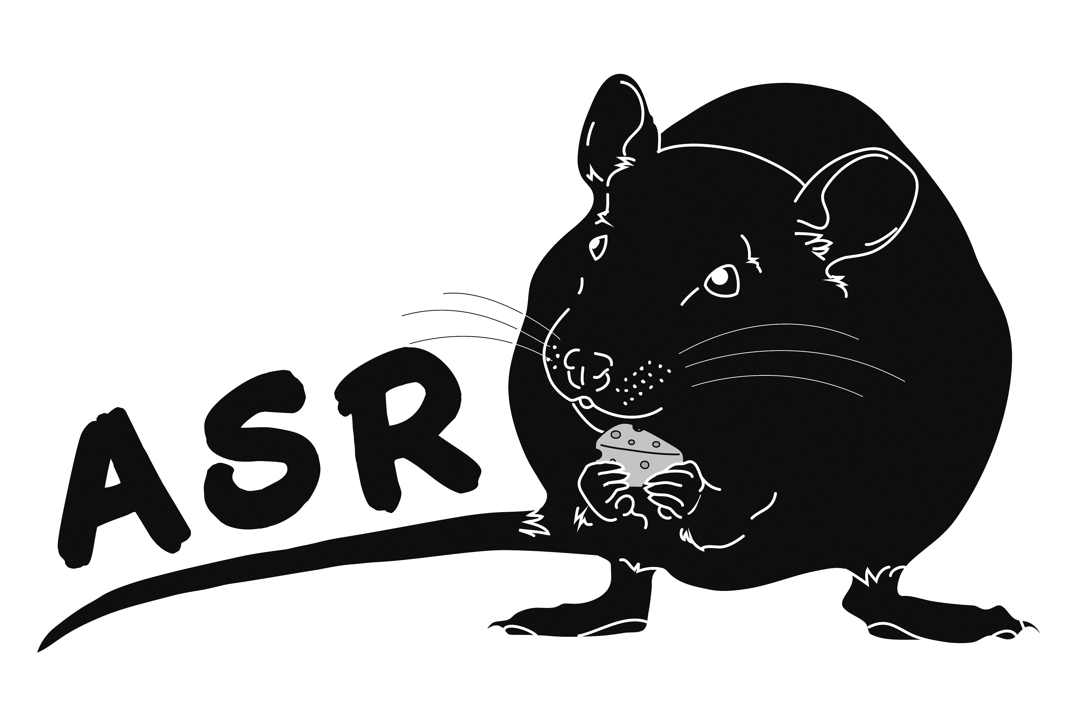
ASSOCIATION DE SPORTS RATIERS

REQUEST FOR APPROVED COMPETITION
Event date :
Organizing Club :
Location :
Trial Organiser :
Email :
Judges :
Types and quantities of searches
 | Level | Number of runs |  | Master | Number of runs
Barn | Novice |  | Barn | Novice
 | Advanced |  |  | Advanced
 | Expert |  |  | Expert
 | Champion |  |  | Champion
 | Gr Champion
 | Excellent
 |  |  |  | Master | Number of runs
Brush | Novice |  | Brush | Novice
 | Advanced |  |  | Advanced
 | Expert |  |  | Expert
 | Champion |  |  | Champion
 | Gr Champion
 | Excellent
 |  | Number of runs
Go-To-Ground | Novice
 | Advanced
 | Expert
 | Champion
 | Excellent
 |  | Wooded Area | Wood / Brush | Brush
Ratissage | Novice |  | xxxxxxxxxxxx | xxxxxxxxxxxx
 | Advanced |  | xxxxxxxxxxxx | xxxxxxxxxxxx
 | Expert |  | xxxxxxxxxxxx | xxxxxxxxxxxx
 |  | Number of runs |  |  | Number of runs
Ga-Rat-Ge indoor | Novice |  | Ga-Rat-Ge ext | Novice
 | Advanced |  |  | Advanced
 | Expert |  |  | Expert
 | Champion |  |  | Champion
 |  | Number of runs
Barn Relay
Brush Relay
Combo
4 by 4
Challenge
 | Number of runs
 | Novice | Advanced | Expert | Champion | Excellent
Rat-Mouflage |  |  |  |  | xxxxxxxxxxxx
Rat-Byrinthe |  |  |  |  | xxxxxxxxxxxx
Rat-Haut
IMPORTANT:
• Use only one form per trial per day
• Maximum of 4 searches of the same type/level per day of trial
• Your waiver form must state that neither the ASR nor its representatives can be held responsible in the event of incidents/accidents
Submit your request to the ASR secretary:
sportsratiers@gmail.com
 |  |  |  | Revised July 2025

